

Part A 小作文 信件
Suppose you won a translation contest and your friend Jack wrote an email to congratulate you, and ask advice on translation. Write him a reply to
1)thank him;
2)give your advice.
You should write neatly on the ANWSER SHEET. Do not sign you own name at the end of the letter, use “Li Ming ” instead. Do not write the address .(10 point)

大作文
48.Directions:
Write an essay based on the following chart. you should
1) interpret the chart and
2) give your comments.
You should write about 150 words on the ANSWER SHEET.(15 points).
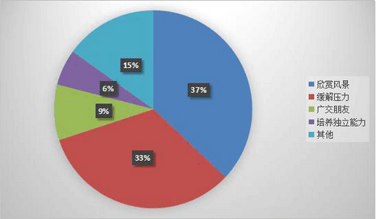
某高校大学生旅游目的调查
（大学生旅游的目的 各不相同---in a certain university))

Section IV Writing
Part A
47. Directions:
Suppose you are invited by Professor Williams to give a presentation about Chinese culture to a group of international students. Write a reply to
1）Accept the invitation, and
2）Introduce the key points of your presentation.
You should write neatly on the ANWSER SHEET.
Do not sign you own name at the end of the letter, use “Li Ming ” instead.
Do not write the address .(10 points)

48. Directions:
Write your essay on ANSWER SHEET. (15 points)
You should
1) interpret the chart, and
2) give your comments.
You should write about 150 words on the ANSWER SHEET. (15points)

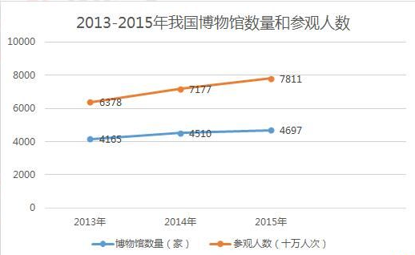

Section ⅣWriting
Part A
47. Directions:
Suppose you have to cancel your travel plan and will not be able to visit professor Smith. write him an email to
1)apologize and explain the situation, and suggest a future meeting
2)You should write about 100 words on the ANSWER SHEET.
Do not use your own name. Use “Li Ming” instead.
Do not write your address.(10 points)

Part B
48. Directions：Write an essay based on the chart below. In your writing you should
1)interpret the chart,and
2)give your comments
You should write about 150 words on the ANSWER SHEET.(15 points)

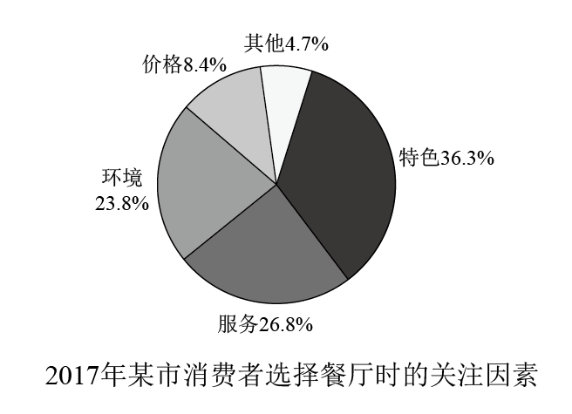

Section ⅣWriting
Part A
- Directions:
Suppose you have to cancel your travel plan and will not be able to visit professor Smith, write him an email to Suppose Professor Smith asked you to plan a debate on the theme of city traffic. Wrote him an email to
  - suggest a specific with your reasons, and
  - tell him about your arrangements.
You should write about 100 words on the ANSWER SHETE. Do not use your own name. Use “Li Ming” instead(10 points)

Part B
- Directions：Write an essay based on the chart below. In your writing, you should
  - interpret the chart,and
  - give your comments
You should write about 150 words on the ANSWER SHEET.(15 points)

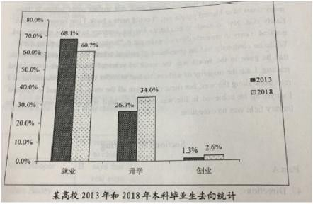

Section IV Writing
Part A
47. Directions:
Suppose you are planning a tour of a historical site for a group of international students. Write an email to
1) tell them about the site, and
2) give them some tips for the tour
Please write your answer on the ANSWER SHEET .
Do not use your own name, use“Li Ming”instead. (10 points)

Part B
48. Directions:
Write an essay based on the chart below. In your writing, you should
1) interpret the chart, and
2) give your comments.
You should write about 150 words on the ANSWER SHEET. (15 points)
2%
17%
20.5%
59.5%
某高校学生使用手机阅读目的

Section IV Writing
47. Directions: Suppose your class is to hold a charity sale for kids in need of help. Write your classmates an email to
1) inform them about the details, and
2) encourage them to participate.
You should write about 100 words on the ANSWER SHEET.
Do not use your own name; use “Li Ming” instead.
Do not write your address. (10 points)

48. Directions: Write an essay based on the following chart. In your writing, you should
1) interpret the chart, and
2) give your comments.
You should write about 150 words on the ANSWER SHEET. (15 points)
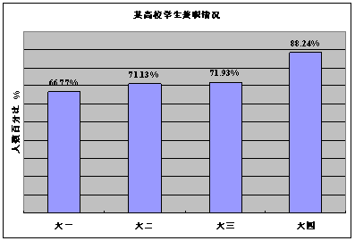

Section IV Writing
Part A
47. Directions:
Suppose you are going to study abroad and share an apartment with John, a local student. Write him to email to
1) tell him about your living habits, and
2) ask for advice about living there.
You should write about 100 words on the ANSWER SHEET.
Do not use your own name. Use “Li Ming” instead.
Do not write your address. (10 points)

Part B
48. Directions:
Write an essay based on the following chart. In your writing, You should
1) interpret the chart, and
2) give your comments.
You should write about 150 words on the ANSWER SHEET. (15points)
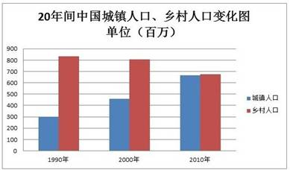

Section IV Writing
Part A
47. Directions:
Suppose your university is going to host a summer camp for high school students. Write a notice to
1) briefly introduce the camp activities, and
2) call for volunteers.
You should write about 100 words on the ANSWER SHEET.
Do not use your name or the name of your university.
Do not write your address. (10 points)

Part B
48. Directions:
Write an essay based on the following chart. In your writing, you should
1) interpret the chart, and
2) give your comments.
You should write about 150 words on the ANSWER SHEET. (15 points)
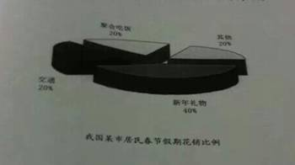

Section Ⅳ Writing
Part A
- Directions：
Suppose you are organizing an online meeting. Write an email to Jack, an international student, to
- invite him to participate, and
- tell him the details.
You should write about 100 words on the ANSWER SHEET.
Do not use your own name. Use “Li Ming” instead.
Do not write your address. (10 points)

- Directions：
Write an essay based on the chart below. In your writing, you should
- interpret the chart, and
- give your comments.
You should write about 150 words on the ANSWER SHEET. (15 points)

